The Beach Boys (MFP 1382)

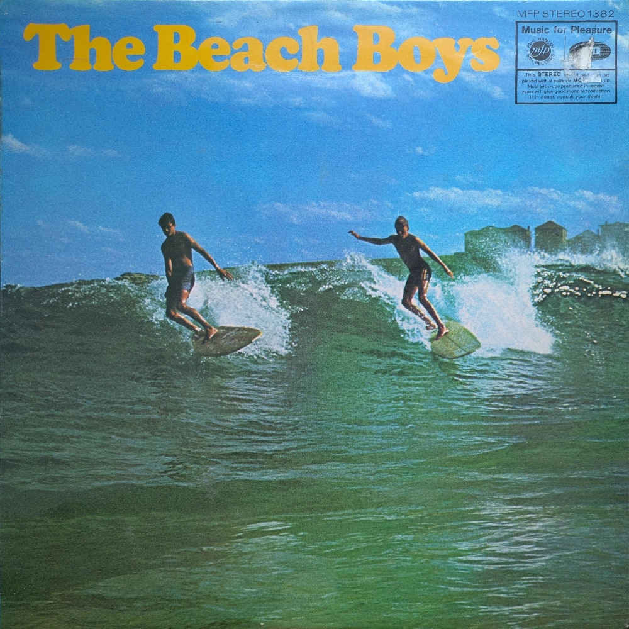
EMI acquired Capitol in 1955, their focus was primarily on popular music and their roster was incredibly strong, Nat King Cole, Frank Sinatra and latterly the Beach Boys. Now, this is not a best of or a greatest hits, and to be fair it is not marketed as such - simply The Beach Boys. The scattergun tracklist is entirely in keeping with MFP’s wider methodology.

One criticism that I have met online about the label is that the records were poorly pressed. If there is anything to take away from this zine it is this: MFP records are generally very well pressed. These records may well have been mistreated, even trashed, but the UK records were generally pressed at the Hayes plant in Middlesex and likely would have gone through better quality control than would be the case today.

This Beach Boys album is a great example this and the sort of record I think we would like to see being repressed today - a well known band, a good mix of tunes, well packaged and cheap.

